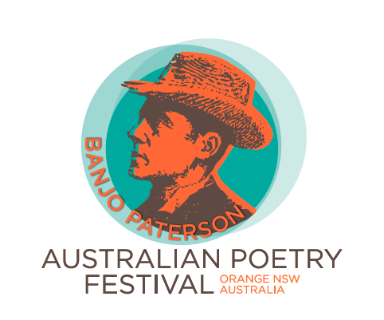

Banjo Paterson Australian Poetry Competition 2019
For individual performance of original poetry

Performance and judging will be on Saturday 23 February 2019 in the Orange Ex Services Club, Orange NSW. Actual performance times during the day will be advised when entries are collated.

Classes:

- Open – for any individual contestants
- Novice Recital – for individual contestants who have not won first prize in a poetry recital competition
- Novice Reading – for individual contestants who wish to read their poem
- High School students – for individual contestants who are attending high school in 2019
- Primary School students – for individual contestants who are attending primary school in 2019

Prizes:

Class 1 Open: first prize $600; second prize $300; third prize $100
Class 2 Novice Recital: first prize $400: second prize $200; third prize $50
Class 3 Novice Reading: first prize $300: second prize $150; third prize $50
Class 4 High School: first prize $200: second prize $100; third prize $50
Class 5 Primary School: first prize $200: second prize $100; third prize $50

Conditions of entry:
- Poems are to be original works.
- Poems should generally be rhyming verse.
- Poems and performances are not to be offensive and must be suitable for family entertainment.
- Poems are to be performed by the poet, in person, at the event.
- The performance may include reciting, reading, singing and/or chanting. Reading or use of notes in Classes 1 and 2 will be penalised in the judging and point scoring. Reading or use of notes in Classes 3, 4 and 5 will not be penalised.
- The maximum presentation time is 5 minutes per entry (preamble and postscript are included in the 5 minutes).
- Entrants are to provide their own equipment and props. A microphone and lectern will
be available on stage.
- Judging will be based on guidelines provided by the Australian Bush Poets Association (ABPA) and judges will use the ABPA score sheets.
- Entrants may enter one Class only.
- Entrants may enter one poem only.
- Poems performed in previous Banjo Paterson Australian Poetry Competitions, Orange, must not be entered in this 2019 competition.
- Entries are accepted once the entry fee is paid.
- There is no need to submit a copy of the poem.
- The entry fee for the Open and Novice Classes is $5 per entry.
- Entry for the High School and Primary School Classes is free.
- Entry fees are payable by cheque to Rotary Club of Orange Inc or by direct deposit to the Rotary Club of Orange Project Account.
- Entries close at 5 pm on Wednesday 13 February 2019.
- Entrants will be notified by email before Monday 18 February 2019 of the time of their performance.

Post or email entry forms to: Send cheque with entry form or
make electronic payment to:
Rotary Club of Orange Inc.
PO Box 52 Rotary Club of Orange Project Account
ORANGE NSW 2800 BSB: 082774; Account number: 509857605
contact@rotarycluboforange.org.au

Contact person: Len Banks lmbanks@bigpond.com or 0428 459 117

For more information about the Banjo Paterson Australian Poetry Festival 2019, see www.banjopatersonfestival.com.au

Banjo Paterson Australian Poetry Competition 2019
ENTRY FORM

Please use one entry form per contestant.
Entries close 5 pm Wednesday 13 February 2019.

Name of poet/contestant:

Postal address:

Email address:

Contact phone number:

Open Class entry @ $5 per entry (title):

Novice Recital Class entry @ $5 per entry (title):

Novice Reading Class entry @ $5 entry (title):

High School Class entry @ free entry (title):

Primary School Class entry @ free entry (title):

I agree to the conditions of entry. Signature of contestant:……………………………..

Entry fee: $....................

Post or email entry forms to: Send cheque with entry form or
make electronic payment to:
Rotary Club of Orange Inc.
PO Box 52 Rotary Club of Orange Project Account
ORANGE NSW 2800 BSB: 082774; Account number: 509857605
contact@rotarycluboforange.org.au

